APP Name : **ios Web View App**

How TO Reskin app

**Change icon**

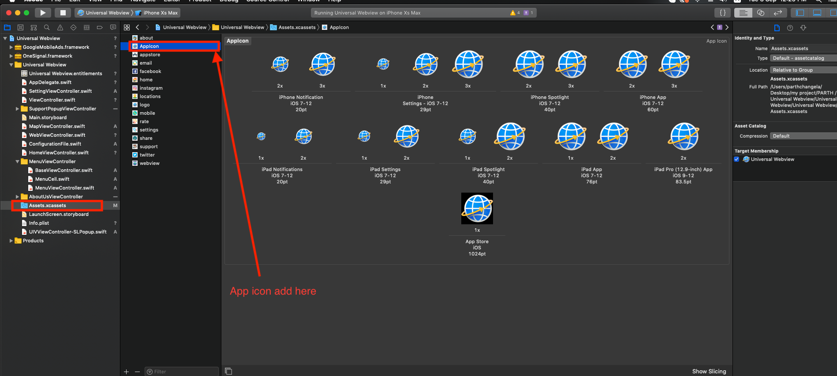

1) first you need put your icon in assests

**How to change ads mob id**

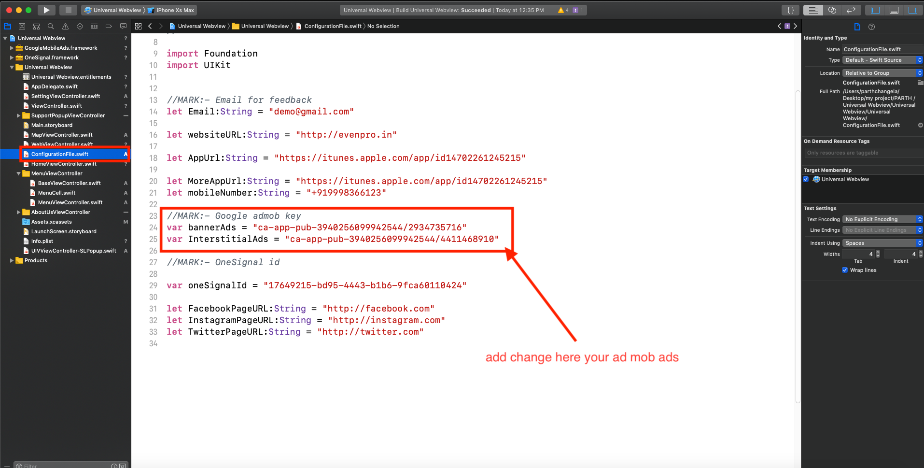

just you go this path

ConfigurationFile.swift

**Change app Title**

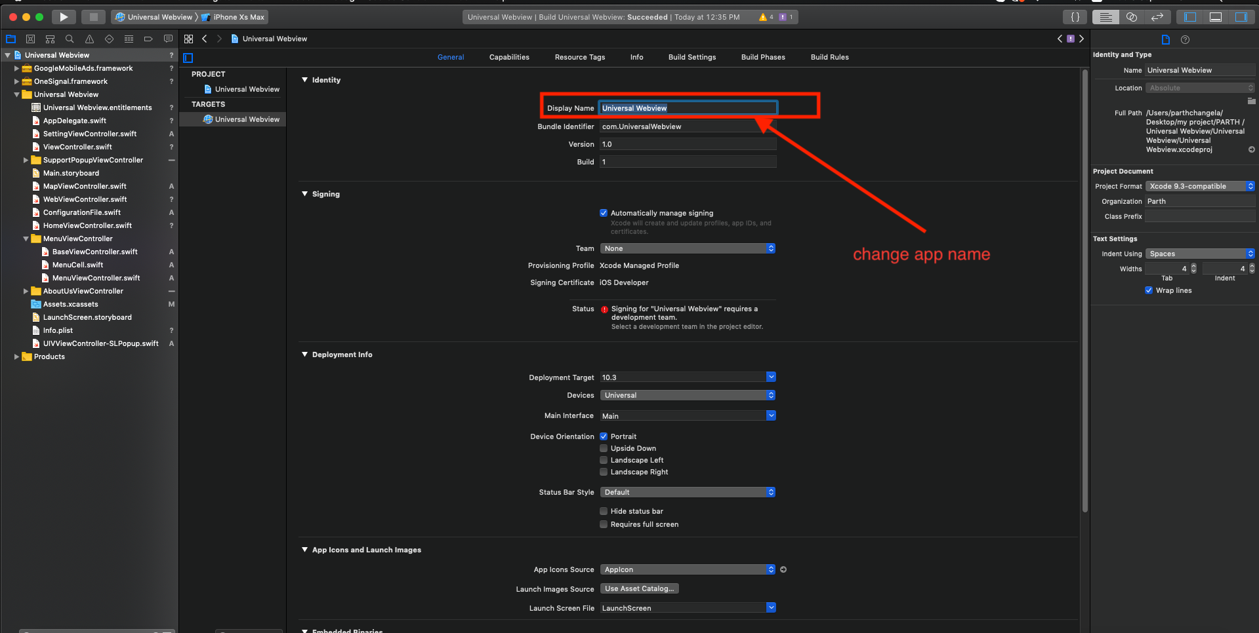

**Change app Bundle Identifier**

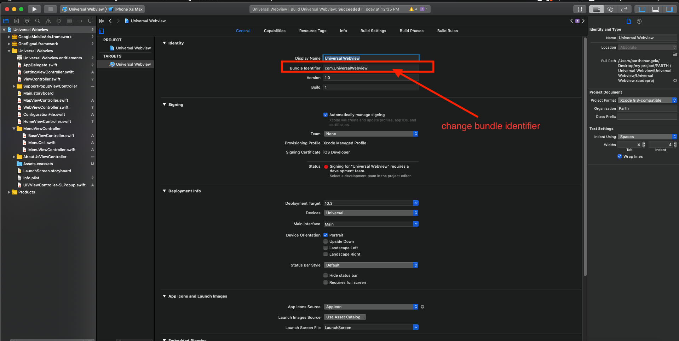

**Change app social media page url**

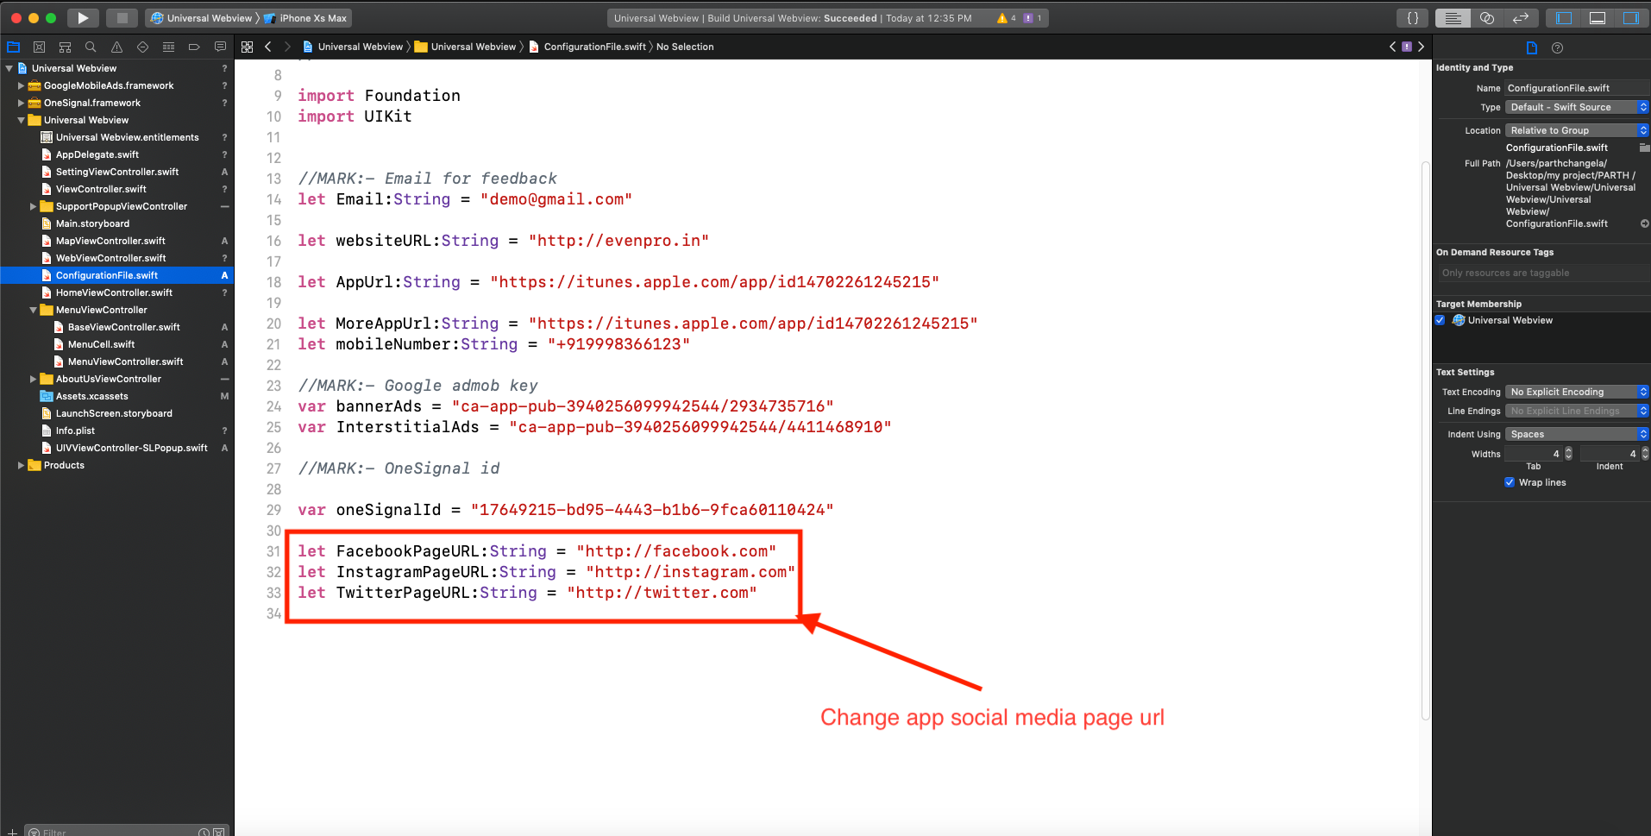

**Change app website url**

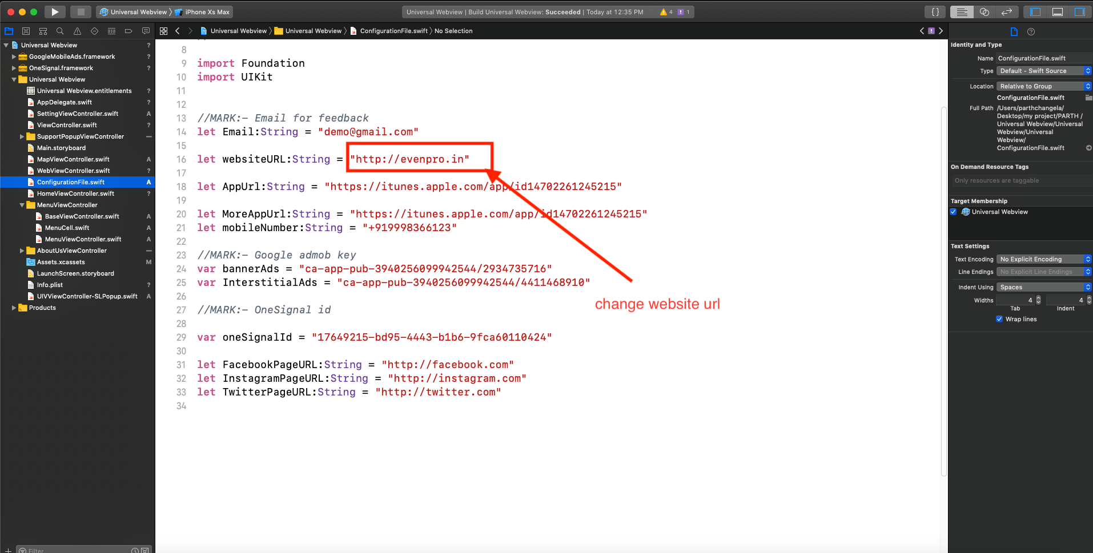

**Change app Support contact detail**

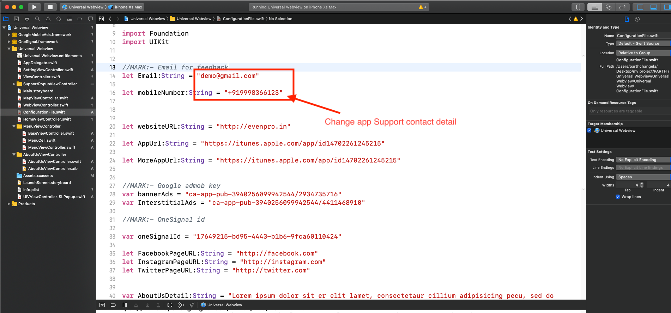

**Change app aboutus detail**

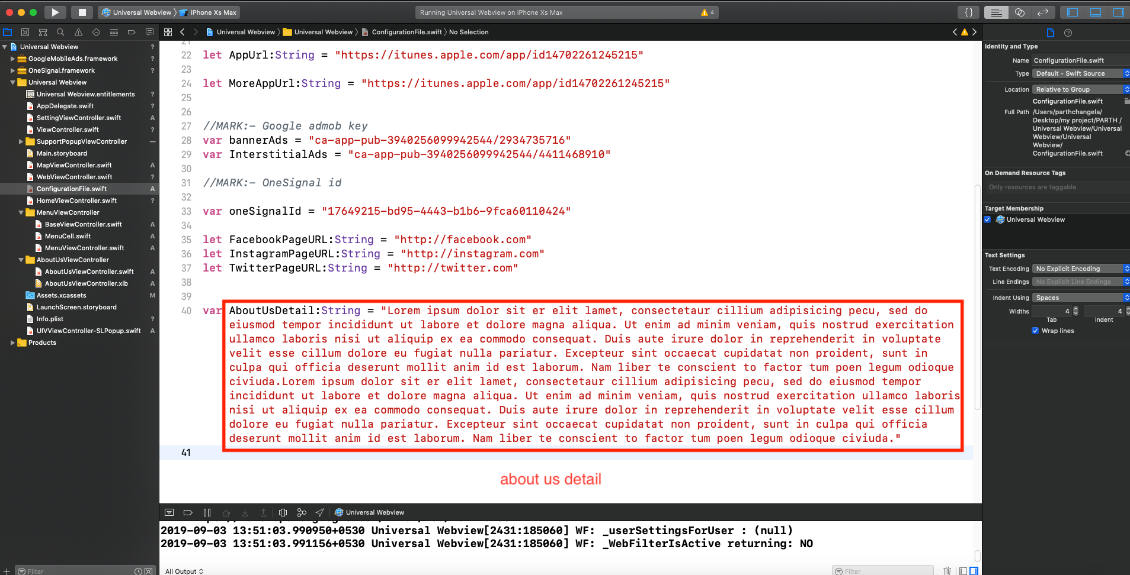

**Change app url and account url**

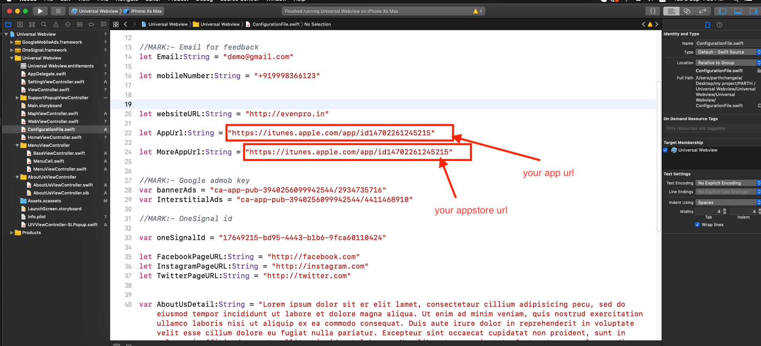

**Change onesignal id**

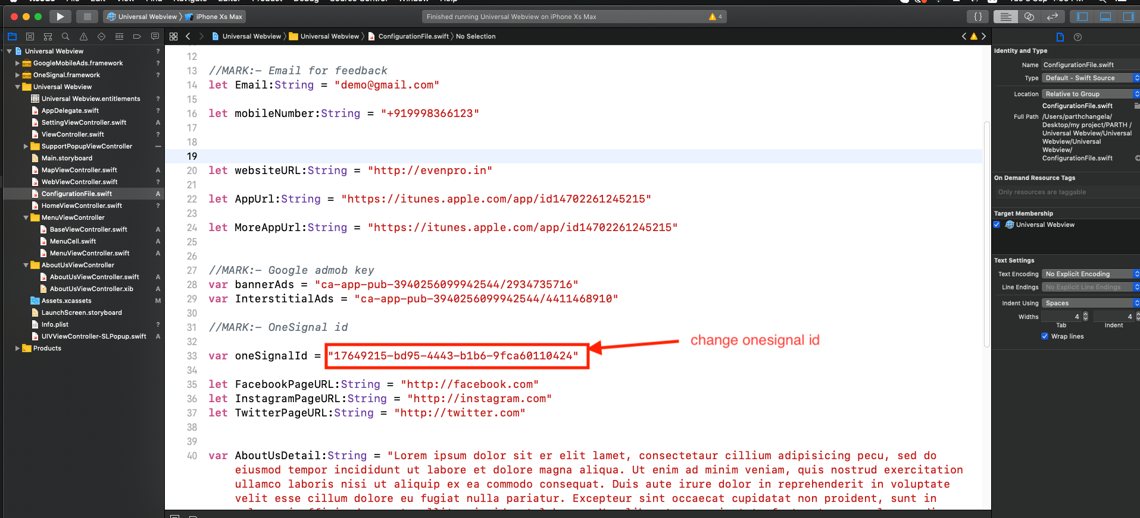

Reskin / Installation:-  
------------------------------------------------------------------  
  
1. Upload app in app store  
2. Redesign Application.  
3. Customize Admob.

4. if client need more images we add.

Above charge Just in $50.

* All design and app store developer account provide by the client.

Support Policy:-  
-----------------------------------------------------------------  
  
1. We always here to support you. Provide as much detail as you can and we will surely resolve your problems.

2. We provide support through Skype, Email and Mobile.

Email id- [info@thenextwebs.com](mailto:vora.hari12@gmail.com)

3. We may not respond to comments or providing support during Holidays and weekend.

Working Days : Monday to Friday.  
Business Hours : 10:00 AM to 06:00 PM  
Time zone : GMT +5:30